Silo thinking and why it is bad...
by Gary Comerford on Monday

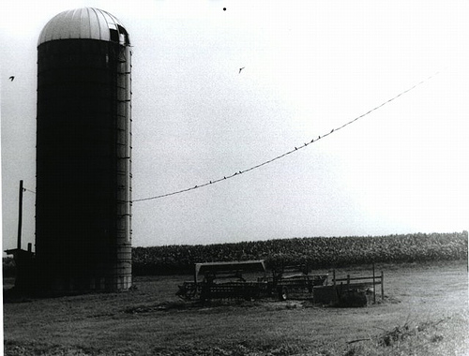by Dave Winer

What is Silo thinking?
When everyone in an organisation is organised and works around the concept of individual functions or departments. This encourages introversion and also decreases efficiency.

Causes of Silo thinking
Silo’s originate historically as a result of many factors: Original organisation of departments or mergers and acquisitions through the years are two examples. As each of these has occurred the impact it has on the organisation is to make each part a little more insular. An 'us-vs-them' mentality can sometimes appear. Alternatively the method of budgeting and appraising departments and employees can lead to a specific mindset. For example if your budget for next year (and your bonus for a successful performance) is based on the performance of your department or your function, then you would focus on making sure your department (and, by extension you), was successful. This could be to the detriment of the company as a whole. This is what causes silo thinking.

Why is it bad?

What’s the problem with a silo? It is usually incredibly focused and efficient within its own structures. Let me tell you a story about why this is bad: I worked with an organisation that had put into place an enterprise architecture function. This function was global, cross-silo and mandated the technological direction of the company. They defined a set of standards for numerous technologies etc. This worked for a large proportion of the company but didn’t work for a research function who ALWAYS wanted to go outside the boundaries. They were a silo which cost the company money. Yes, of course they always had legitimate reasons for wanting to go outside the published standards, but these reasons were merely ways to propagate the fact that they were intent on staying as a self-governing silo within the organisation. As such they were costing the company money and shouldn’t have been allowed to continue. The problem was that they were ‘an important part of the company’ and as such they were allowed ‘special dispensation’ to do what they wanted because they were 'key to the survival of the company'. There logic was ‘if we didn’t exist as a department the company would have no products to market, manufacture and sell. Therefore you should be beholden to us’. Strictly speaking this was absolutely true. But the same logic could be used by manufacturing ‘If we didn’t exist nobody would be able to make the products you have created, marketed and wish to sell’ So in that respect they were also key to the continued existence of the company. You can take that logic to an extreme and say if the sales department didn’t exist then there would be nobody to sell the products that were created, marketed and manufactured. In truth EVERY department was probably crucial to the successful existence of the company (with the possible exception of HR), But that didn’t mean they could all be treated as a) unique and b) indispensable.
The truth of the matter was that EVERY department could be outsourced to some other organisation. EVERY member of each department could be replaced by a contract individual from a third-party company. Nobody was immune. In fact when things got tight during periods of patent expiry and cost cutting a large number of people from some of the departments mentioned above were let go. Obviously in a company there are certain parts that you don’t try to outsource - primarily those parts of the company which are your unique selling point, or the parts that give you a competitive advantage. But even those departments will not give you a competitive advantage if they continue to treat themselves as unique entities which are divorced from the rest of the organisation. That is one facet of silo thinking.

Another facet of silo thinking is looking at a problem as being either all yours to deal with or not yours to deal with at all. This is usually where process type problems occur. Take, for example, the department which decides that they are going to change the part of a global process that they are responsible for. They may - for example - remove an internal quality check in a product review process. As a result the whole process can be accomplished x% faster than before. They do this in isolation from the rest of the process and without consultation (“Why should we tell anyone, it’s our part of the process and we are responsible for it?”). As a result the number of faulty items produced is increased at a later stage in the process causing re-work and delays. Overall the process becomes slower and less efficient - all as a result of silo thinking.
Remedies for Silo Thinking

Solving the issue of silo thinking in organisations is very easy. Remove the silos. This is, of course, easier said than done. How can an organisation which may have traditionally been organised along functional or departmental lines suddenly change to be organised a different way? Well I think that key to understanding this issue is remembering that we are looking at human behaviour here. There are only two ways of changing human behaviour 1) Punish adherence to the old behaviours 2) Reward adherence to the new behaviours.
These are traditionally known as 'The Stick and The Carrot'. But other than that you need to go back and try to discover the reasons for the silo behaviour.

- Is it an organisational thing? If so, change the organisation.
- Is it a reward and recognition thing? If so change the reward systems to penalise silo behaviours.
- Is it an historic artefact caused by the merging of two rival companies? If so implement the stick and the carrot to incentivise people to change their behaviour.
- Is it a process thing? (You knew we would get to process ultimately didn't you?) This is something that can definitely be improved. If your processes are causing silo functioning then you have got inadequate and inappropriate processes. Change them. Focus on the process as it affects the whole of the company rather than just how it affects a specific department. Look at removing steps which are there just to please a specific department ("We need an approval on this prior to release because......just because"). Remember a process will generally affect the whole of the organisation - especially if it is a customer focused process. Treat it as a global process and remove the silos.
Summary
Silo's are great if you're storing corn or grain. In an organisation they cause more trouble than they are worth. Get rid of them at all costs. You'll thank me if you do.

